

**YEAR: 7**

**2023**

**SUBJECT: Science**

**Semester 2**

**Term 3**

**TEST: Mixtures**

**TIME: 55 minutes**

**QUESTIONS:** **12 Multiple Choice (12 marks)**

**10 Short Answer (28 marks)**

**TOTAL MARKS: 40 marks**



**SEMESTER 2 2022**

**Mixtures Test:**

**ANSWER BOOKLET**

**NAME:**

**FORM:** **DATE:**

|  |  |
| --- | --- |
| **I CAN STATEMENTS** | **QUESTIONS** |
| **MUST**  Describes techniques for separating given materials from a mixture. Identifies pure substances and mixtures from given examples. | 1, 2, 3, 4, 5, 7, 8, 9, 10, 11, 13, 14, 15, 17, 18 |
| **SHOULD**  Selects and describes appropriate separation techniques based on the physical properties of a number of components of a mixture. Explains the difference between pure substances and mixtures. | 6, 12, 15, 16, 20, 22 |
| **COULD**  Selects and explains the most appropriate separation techniques based on the physical properties of components of a mixture. Explains the difference between pure substances and mixtures with reference to chemical bonds | 19, 21 |

**ASSESSMENT KEY**

Multiple Choice Short Answer Total

**/28**

**/12**

**/40**

**SECTION ONE:** Multiple choice answers

Cross (X) through the correct answer.

|  |  |  |  |  |
| --- | --- | --- | --- | --- |
| **1** | a | b | c | d |
| **2** | a | b | c | d |
| **3** | a | b | c | d |
| **4** | a | b | c | d |
| **5** | a | b | c | d |
| **6** | a | b | c | d |
| **7** | a | b | c | d |
| **8** | a | b | c | d |
| **9** | a | b | c | d |
| **10** | a | b | c | d |
| **11** | a | b | c | d |
| **12** | a | b | c | d |

**SECTION TWO: Short Answer (28 marks)**

**Answer the questions in the spaces provided.**

1. Define the following terms:
2. Pure substance (1 mark)

|  |
| --- |
|  |
|  |

1. Colloid (1 mark)

|  |
| --- |
|  |
|  |

1. Simple separation (1 mark)

|  |
| --- |
|  |
|  |

1. Read the following statements and answer the following questions:

Salt crystals do NOT dissolve in cold water.  
Salt crystals do NOT dissolve in boiling water.  
Sugar does dissolve in water.  
Sugar does NOT dissolve in kerosene.  
Kerosene does NOT dissolve in water (3 marks)

1. **Identify** the solvent you would use to make a solution containing salt crystals.

**____________________________________________________________________**

1. **Identify** two substances that are insoluble in water.

**____________________________________________________________________**

1. I**dentify** a substance that is soluble in water.

**____________________________________________________________________**

1. Graffiti remover is used to wash paint from a wall. A) Is the paint the solvent b) solute or c) solution? **Explain your answer**. (3 marks)

|  |
| --- |
|  |
|  |
|  |
|  |

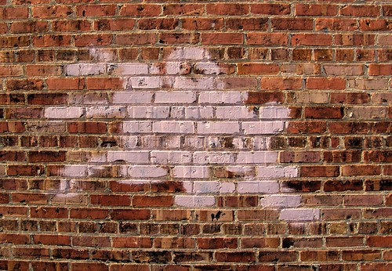

1. Your little sister is watching you put a teaspoon of sugar into a glass of hot water. She makes a comment that ‘the sugar has disappeared”. How do you explain the “disappearance” of the sugar to her? (2 marks)

|  |
| --- |
|  |
|  |
|  |
|  |

1. List two examples of filtering or sieving used around the home. (2 marks)

Example 1: __________________________________________

Example 2: __________________________________________

1. Evaporation is a technique used to separate substances.
2. Give an example of a mixture where evaporation is used to separate substances. (1 mark)

|  |
| --- |
|  |

1. Draw a labelled diagram using correct science skills of the equipment you would use in evaporation. (4 marks)

|  |
| --- |
|  |

1. Using an **example**, **explain** how the process by which chromatography can separate substances. Draw a diagram if possible. (3 marks)

|  |
| --- |
|  |
|  |
|  |
|  |
|  |
|  |
|  |

1. In gold panning, a mixture of gravel and gold particles are swirled around in water and the gold remains in the pan while the gravel is swirled out into the river with some of the water. **Explain** this separation method. A diagram may be helpful. (2 marks)

|  |
| --- |
|  |
|  |
|  |
|  |
|  |
|  |
|  |

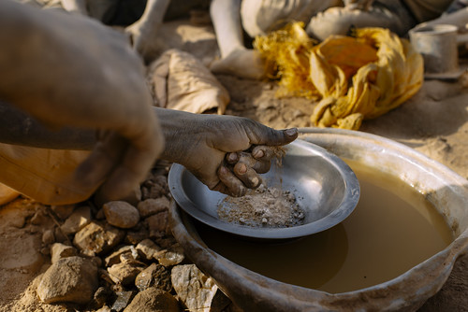

1.  Magnetic separation is used in science. (3 marks)
2. Provide an example

|  |
| --- |
|  |
|  |
|  |
| 1. Explain the separation process |
|  |
|  |

1. Explain how a boiling point of a liquid can be used to separate a mixture. Draw a diagram please. (2 marks)

|  |
| --- |
|  |
|  |
|  |
|  |

**END OF TEST**

**Please check your work!**